**Quiz#03**

**Q.No.1.** Convert the following **NFA-˄** into FA. Draw Transition table corresponding to required FA **(Marks=05)**

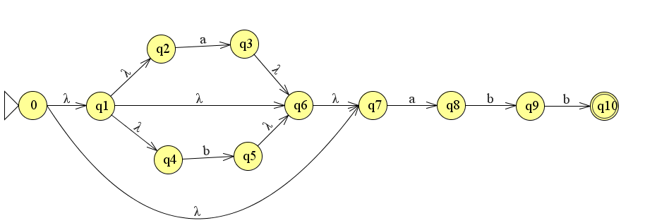

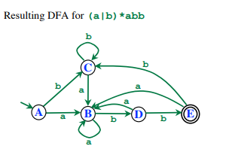

**Q.No.2.** Convert the following Non-Deterministic Finite Automata (NFA) to Deterministic Finite Automata (DFA) **(Marks=05)**

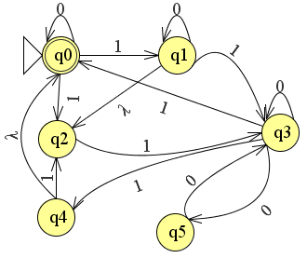

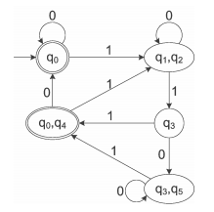

**Q.No.3.** Convert the following Non-Deterministic Finite Automata (NFA) to Deterministic Finite Automata (DFA) **(Marks=05)**

